**Ablative Material**

Ablation is the removal of material from an object by an erosive processes, such as chipping, and vaporization.

Spaceflight use:  ablative material is designed so that instead of heat being transmitted into the structure of the spacecraft, only the outer surface of the material bears the majority of the heating effect. The outer surface chars and burns away -- but quite slowly, only gradually exposing new fresh protective material beneath. The heat is carried away from the spacecraft by the gases generated by the ablative process.

**Tangent Ogive**

[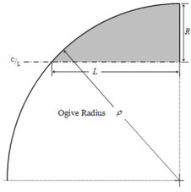](https://en.wikipedia.org/wiki/File:Nose_cone_tangent_ogive.png)[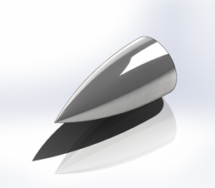](https://en.wikipedia.org/wiki/File:Tangent_Ogive_Nose_Cone_Render.png)



Tangent ogive nose cone render and profile with parameters and ogive circle shown.

Next to a simple cone, the tangent [ogive](https://en.wikipedia.org/wiki/Ogive) shape is the most familiar in [hobby rocketry](https://en.wikipedia.org/wiki/Model_rocketry). The profile of this shape is formed by a segment of a [circle](https://en.wikipedia.org/wiki/Circle) such that the rocket body is [tangent](https://en.wikipedia.org/wiki/Tangent) to the curve of the nose cone at its base, and the base is on the radius of the circle. The popularity of this shape is largely due to the ease of constructing its profile, as it is simply a circular section.

The radius of the circle that forms the ogive is called the *ogive radius*, *ρ*, and it is related to the length and base radius of the nose cone as expressed by the formula:

**DAQ**

NI National Instruments

USB-6212

16 input 16 bit 400kS/s

Multifunction I/O{\displaystyle \rho ={R^{2}+L^{2} \over 2R}}

**Video Descriptions**

August 20th 2019.

Click then ignition will start, dark grey smoke.

After 5 sec, oxidizer will flow.

Nozzle disassembly followed by pure oxidizer flow.

Slow motion replay.

March 6th 2020.

Click then ignition will start, dark grey smoke.

After 3 sec, Oxidizer flow

Engine cut, out-reignition then final cut out.

March 20th 2020.

Click then ignition will start, dark grey smoke.

After 3 sec, Oxidizer flow

After 10 sec burn time, something will happen.

Note: Aluminum melting point: 1,200deg F or 660 deg C.

**Runaway Isp Issue**

Merlin SL Isp (311s)

Rutherford SL Isp (311s)

**Rocket Dim**

7.5” Diameter

84” or 7’ tall

50lbs or 23kg